

**AMERICAN INTERNATIONAL UNIVERSITY–BANGLADESH (AIUB)**

**FACULTY OF SCIENCE & TECHNOLOGY**

**DEPARTMENT OF PHYSICS**

**PHYSICS 1 LAB**

**Spring 2021-2022**

**Section: B19, Group: 03**

**LAB REPORT ON**

**Verification of Newton's Second Law of Motion by Atwood Machine**

**Supervised By**

**Md. Saiful Islam**

**Submitted By**

|  |  |  |
| --- | --- | --- |
| **Name** | **ID** | **Contribution** |
| **1. Sha Sultan Sowhan** | **22-47014-1** | **Procedure and Experimental Data** |
| **2. Mahmuda Khatun** | **22-47016-1** | **Discussion and References** |
| **3. Farjana Yesmin Opi** | **22-47018-1** | **Analysis and Calculation, Result** |
| **4. Md. Abu Towsif** | **22-47019-1** | **Theory and Apparatus** |

Date of Submission: **February 11, 2022**

**TABLE OF CONTENTS**

|  |  |
| --- | --- |
| **TOPICS** | ***Page no*.** |
| 1. **Title Page** | 1 |
| 1. **Table of Content** | 2 |
| 1. **Theory** | 3 |
| 1. **Apparatus** | 4 |
| 1. **Procedure** | 4 |
| 1. **Experimental Data** | 5 |
| 1. **Analysis and Calculation** | 6 |
| 1. **Result** | 7 |
| 1. **Discussion** | 7 |
| 1. **References** | 7 |
|  |  |

1. **Theory**

Newton's second law of motion can be formally stated as “The acceleration of an object as produced by a net force is directly proportional to the magnitude of the net force, in the same direction as the net force, and inversely proportional to the mass of the object”.So it tells that force causes acceleration and the relationship between net force acting on an object, Fnet and its acceleration, a is: Fnet = ma, where m is the mass of that object.

In Atwood machine, two masses m and M are suspended by a piece of inelastic light string that passes over a pulley in a vertical plane as the fig. 2.1 shows. The two masses are connected with a string, because of this, they must have same tension, T and acceleration,a.

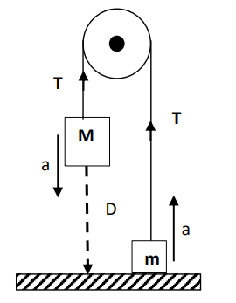

If we consider the upward direction as positive, neglecting friction and mass of the pulley and applying Newton’s second law of motion we get

For M : Fnet = T – Mg = -Ma

For m : Fnet  = T – mg = mg

If we solve these two equations,we get the theoretical acceleration as,

ath = (M-m)

As acceleration due to gravity g is constant in a particular place and taking total mass (M+m) constant for the Atwood machine, according to Newton’s second law we get**,**

Figure 1:Arrangement of an ath  (M – m)

Atwood machine.Here M>m

According to figure 1, the mass M falls a distance D in time t from rest. Applying the knowledge of equations of motion (D = ut +1/2 at2 ), we can calculate the experimental acceleration by,

aex =

For different mass combination, (M-m) we will get different experimental accelerations, aex. If we find a linear relationship between aex and (M-m) for the Atwood machine, we can say that Newton’s second law is verified.

1. **Apparatus**

1.Pulley

    2.Two hangers

    3.Different masses

    4.String

    5.Stand and clamp

    6.Meter scale 

    7.Stop watch

1. **Procedure**

1. We have to hold the lighter mass on the floor attached to one end of a string & keep the heavier one attached to the other end of the string up in to the air at the height 'D' from the floor.

2. Then we measure the height 'D' with a meterscale.

3**.** Now we have to release the lighter mass and measure the time with stop watch that what time it takes for the heavier mass to fall to the floor.

4.Then we test for 7 different mass differences,(M-m) for each run, we get the acceleration value(cm/s2) experimentally as well as theoretically and we have to make sure that total mass (M+m) is always constant.

5.Now using excel we plot acceleration (atn and aex) versus mass difference (M-m) graph.

1. **Experimental Data**

Table :Acceleration for different mass combination

|  |  |  |  |  |  |  |  |
| --- | --- | --- | --- | --- | --- | --- | --- |
| M  (gm) | m  (gm) | Height  D  (cm) | Time  t  (s) | Mean time  t  (s) | aexp =  (cm.s-2) | ath =  (cm.s-2) | (M-m)  (gm) |
| 500 | 200 | 79.5 | 0.56 | 0.55 | 525.619 | 420 | 300 |
| 0.55 |
| 0.54 |
| 475 | 225 | 79.5 | 0.62 | 0.637 | 392.217 | 350 | 250 |
| 0.65 |
| 0.64 |
| 450 | 250 | 79.5 | 0.76 | 0.75 | 282.666 | 280 | 200 |
| 0.74 |
| 0.75 |
| 425 | 275 | 79.5 | 0.80 | 0.8067 | 244.3278 | 210 | 150 |
| 0.83 |
| 0.79 |
| 400 | 300 | 79.5 | 0.90 | 0.9233 | 186.514 | 140 | 100 |
| 0.94 |
| 0.93 |
| 375 | 325 | 79.5 | 1.09 | 1.106 | 129.983 | 70 | 50 |
| 1.10 |
| 1.13 |
| 350 | 350 | - | 0 |  | 0 | 0 | 0 |

**5. Analysis and Calculation**

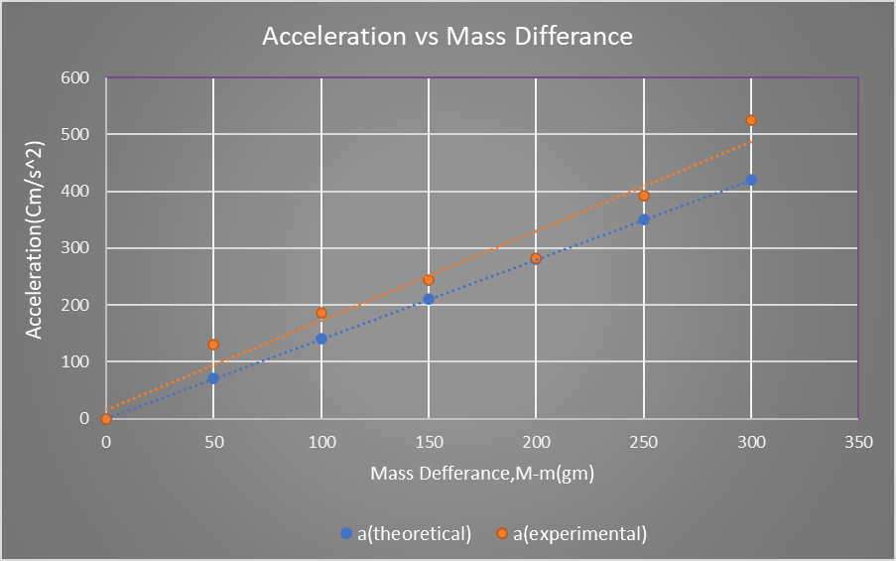

Figure 2:Graph of Acceleration vs Mass Difference(M-m)

**6. Result**

From the “acceleration vs mass difference” graph, the relationship between experimental acceleration and mass difference is directly proportional linear for the Atwood machine same as the theory says. So we can say that Newton's second law is verified.

**7. Discussion**

In the Atwood Machine , Newton’s second law relating the net force, mass, and acceleration was examined, as well as how to use frictionless surfaces and objects, along with a pulley, to confirm this relationship. By using the mass of the cart and adjusting the hanging masses, which changes the acceleration of the cart, we can observe Newton’s second law in effect. Overall, the data supports Newton’s second law, as it only deviates from the law slightly, which could be explained by imperfections in the lab setup and the measurements. One peculiarity of the data was that as the mass increased, the difference between observed acceleration and acceleration predicted by Newton’s second law increased. This may able to be explained by the fact that as the mass increases, the force on the pulley by the string increases, which increases the pulley’s friction. This results in the net force on the cart decreasing, which therefore reduces its acceleration and increases its deviation from the prediction. The friction of the pulley being unaccounted for was one possible source of error in the lab. One other could possibly be the track not being at the most ideal angle to allow the gravitational and normal forces to counteract its own friction.

**8. References**

* 109) Fundamental of Physics (10th Edition): Newton’s second law of motion (chapter 5, page 98-

**Video Links**:

* Newton’s second law: https://www.youtube.com/watch?v=xzA6IBWUEDE
* Atwood Machine: https://www.youtube.com/watch?v=a0KVxh8iPP4